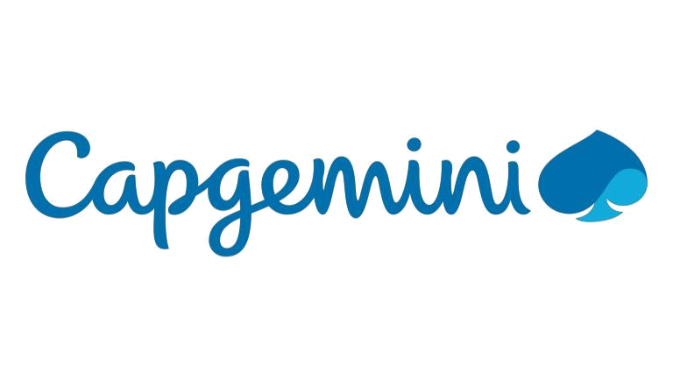

HIGH LEVEL DESIGN & LOW LEVEL DESIGN
1. INTRODUCTION 3

1.1. INTENDED AUDIENCE 3

1.2. PROJECT PURPOSE 3

1.3. KEY PROJECT OBJECTIVES 3

1.4. PROJECT SCOPE AND LIMITATION 3

1.5. FUNCTIONAL OVERVIEW 4

2. DESIGN OVERVIEW 5

3. DETAILED SYSTEM DESIGN 6

3.1. DFD LEVEL 0 6

3.2. DFD LEVEL 1 7

4. ENVIRONMENT DESCRIPTION 7

4.1. TIME ZONE SUPPORT 7

4.2. LANGUAGE SUPPORT 7

4.3. USER DESKTOP REQUIREMENTS 7

4.3.1. Integration Requirements 7

4.3.2. Network 8

5. CONFIGURATION Error! Bookmark not defined.

5.1. Operating System 8

© 2022 Capgemini - All rights reserved Page 2 of 8

Printed copies are current on date of printing only - 11/04/2022. Always refer to the electronic version for the current release.
- Introduction

1.1. Intended Audience

Event management is the application to manage and development of events festivals and conferences. This is an online event management system software project that serves the functionality of an event manager.

project provides most of the basic functionalities required for an event. It allows the user to select from list of event types. Event management system are the best guides who can help you to provide things according to your budgets guides who

can help

1.2. Project Purpose

- Main aim of this project is to develop an online Event Management App.

- Which will be a user-friendly application that lets a customer to plan a decoration for an event.

- Manual hours that need to spend in record keeping and generating reports is no longer required. It generates automatically.

- The data is in a centralized way which is available to all the event managers.

- Easy to manage data in database

- Customer can register for any event from anywhere.

- Event manager can update or modify records of any time.

1.3. Key Project Objectives

- To design and execute memorable events that fulfil our customers wishes.

- Choice of decoration can be made from the list of panels.

- The project will help customer to decorate for an event and the cost required for particular decoration. No need to visit decorator.

- Multiple customers can connect to a single application.

1.4. Project Scope and Limitation

This project allows registered user to login and new users are allowed to get registered on the application. The system helps in the management of events, users and the aspects related to them. This is proposed to be a web application. Users need to login at the initial phase, set his/her profile details including Aadhar no., name, event required, budget, start date, no. of days,

© 2022 Capgemini - All rights reserved Page 3 of 8

Printed copies are current on date of printing only - 11/04/2022. Always refer to the electronic version for the current release.
1.5. Functional Overview

R1: Registration

Description: To enter into this App, user has to register himself first. Requirements of registration are Aadhar no., Name, Budget, Event required, Start Date, End Date, No. of days

Input: User Details
Output: Registration Done

Processing: User details are checked with database, password constraint is Checked as per validation.

R2: User Login

Description: The system provides facility to login into the system.
Input: Enter username and password.
Output: User profile page.
Processing: The system will check the input of user and if valid then login is done.
otherwise, user will be asked to re-enter the username and password.

R3: Select the Event

Description: The user can select the event and also can select the payment method.
Input: Main event, sub event, enrolment number, add team member.
Output: Event selected successfully, see all the details and can delete also.
Processing: The system will add selected data into database.

R4: The Admin Panel

Description: The admin can add event manager, main event, sub events also.
Input: Main event, sub-event
Output: Added successfully into the database.
Processing: The system will add selected data into the database.

R5: Logout

Description: The system provides the facility to logout.
Input: Select logout option.
Output: Logout from the system.
Processing: User will logout.

© 2022 Capgemini - All rights reserved Page 4 of 8

Printed copies are current on date of printing only - 11/04/2022. Always refer to the electronic version for the current release.

- Design Overview

  - Event Management comprises of the following modules in maintain database:

Name of the Module | Register
Handled by
Description | Customer needs to register by providing the details
 | i.e., Aadhar no., name, mobile no.
Name of the Module | Login
Handled by
Description | The customer can directly login. by providing the
 | username and password if he/she is an existing
 | customer.
Name of the Module | Event Details
Handled by
Description | The customer needs to enter the event details such
 | as event type, event date, no. of days and budget.
Name of the Module | Admin
Handled by
Description | Admin can be able to edit, delete customer and event
 | manager’s details.

© 2022 Capgemini - All rights reserved Page 5 of 8

Printed copies are current on date of printing only - 11/04/2022. Always refer to the electronic version for the current release.

- Detailed System Design

3.1. DFD Level 0
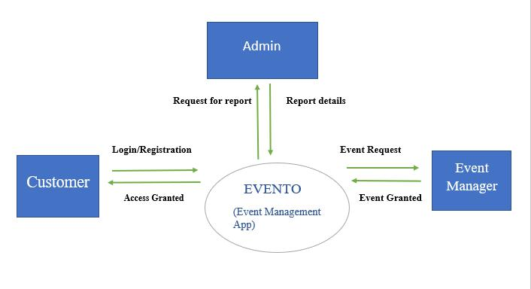

© 2022 Capgemini - All rights reserved Page 6 of 8

Printed copies are current on date of printing only - 11/04/2022. Always refer to the electronic version for the current release.
3.2. DFD Level 1
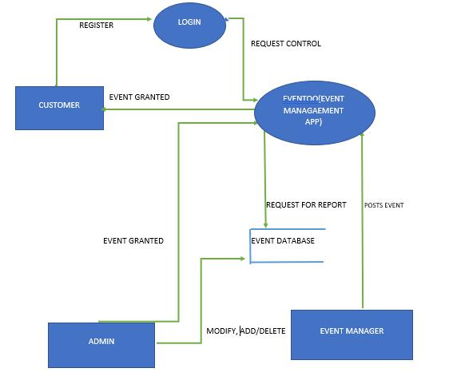

- Environment Description

4.1. Time Zone Support

IST-Kolkata

4.2. Language Support

English

4.3. User Desktop Requirements

- 64-bit processor, 1 GHz or faster

- At least 10 GB free hard drive space

- At least 1 GB RAM Server

4.3.1. Integration Requirements

- Language: - C

- Tools: - Val grind, Make file, Ctag, Cscope, Splint.

- Complier: - gcc

- Linux Environment

© 2022 Capgemini - All rights reserved Page 7 of 8

Printed copies are current on date of printing only - 11/04/2022. Always refer to the electronic version for the current release.
4.3.2. Network

End to End

- Configuration 5.1 Operating System

© 2022 Capgemini - All rights reserved Page 8 of 8

Printed copies are current on date of printing only - 11/04/2022. Always refer to the electronic version for the current release.

